1. 
2. Sometimes, we need to share collection object across multiple threads.
3. 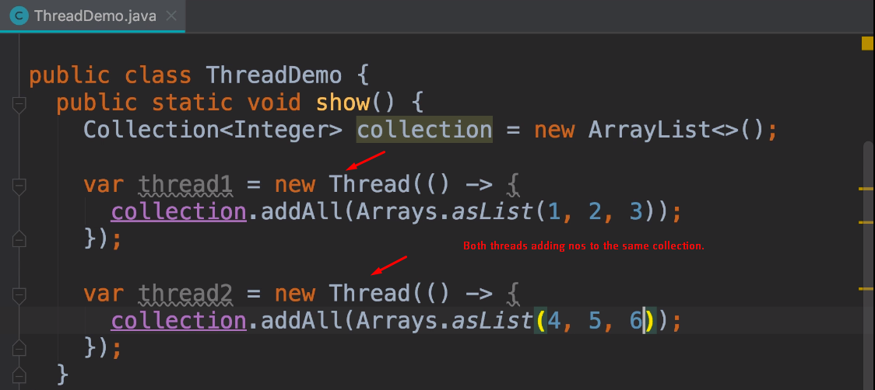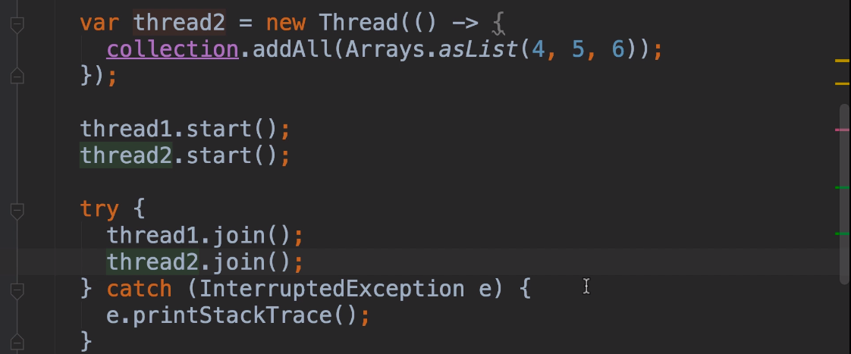
4. 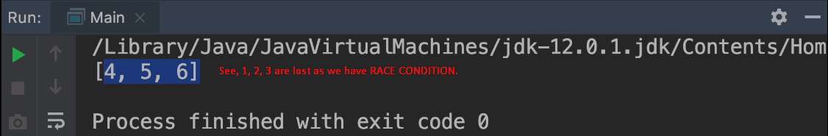
5. **Solution**: We can use synchronized version of collection which is actually a wrapper around the regular collection in java.
6. 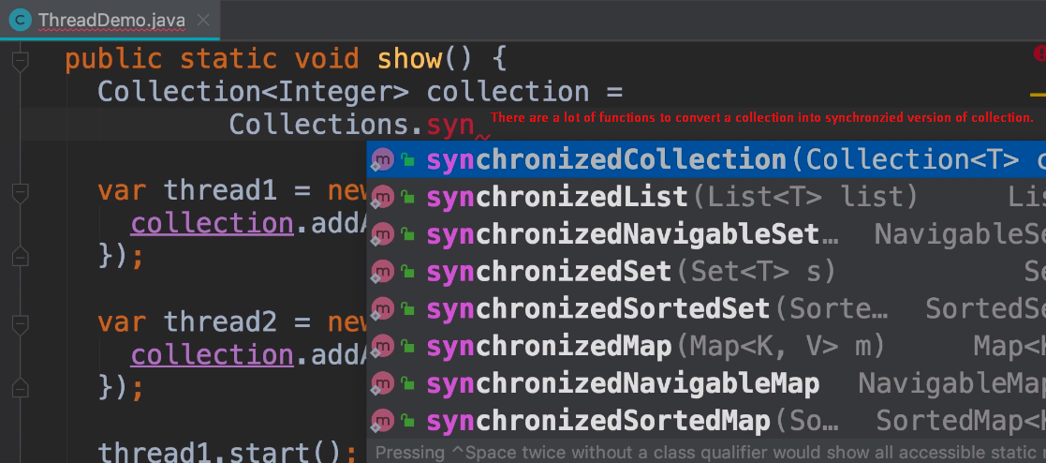
7. 